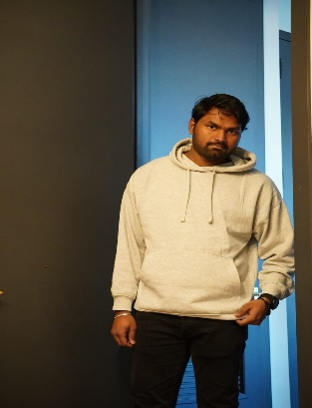 Name: Rathan Jayanath Singavarapu

Email: rs28795n@pace.edu

Role: Team Lead / Full Stack Developer/Scrum Master

Responsibilities:

* Manage team coordination, technical decision-making, sprint planning and timeline adherence.
* Ensure best practices in coding, security, and system performance.
* Develop and maintain the application’s front-end (React) and back-end (Node.js) to ensure seamless user experience. Integrate AWS S3 for secure storage of medical images and user data.
* Maintain structured and detailed documentation of system architecture, APIs, and workflows.

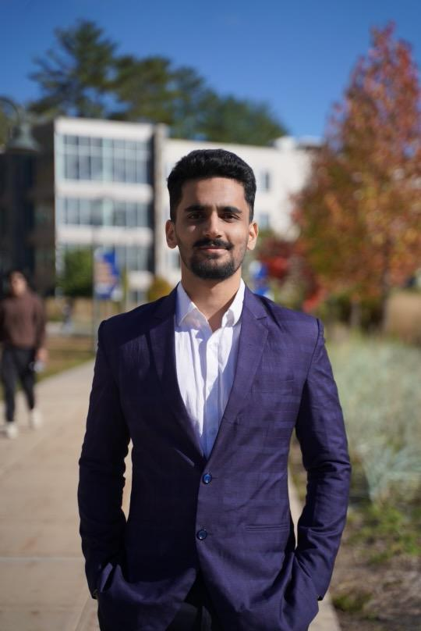 Name: Koundinya Pidaparthy

Email: kp10566n@pace.edu

Role: Lead Full Stack Developer

Responsibilities:

* Ensure smooth execution of Scrum methodologies, including sprint planning, stand-ups, and retrospectives.
* Ensure best practices in coding, security, and system performance.
* Implement database structures in MongoDB for efficient storage and retrieval of medical records.
* Maintain structured and detailed documentation of system architecture, APIs, and workflows.

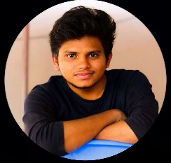 Name: Avinash

Email: am21869n@pace.edu

Role: Full Stack Developer and UI/UX Designer

Responsibilities:

* Develop and maintain the application’s front-end (React) and back-end (Node.js) to ensure seamless user experience.
* Implement database structures in MongoDB for efficient storage and retrieval of medical records.
* Establishing basic design using Figma for the application.
* Maintain structured and detailed documentation of system architecture, APIs, and workflows.

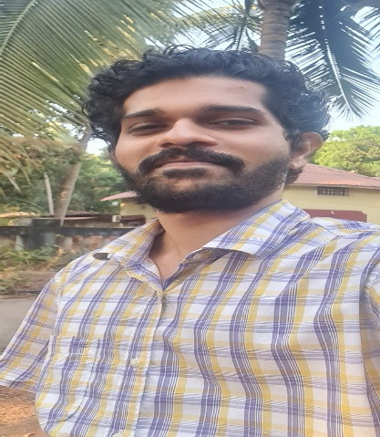 Name: Sujit Suprabhat Tubki

Email: st13486n@pace.edu

Role: Tester/Quality Assurance

Responsibilities:

* Conduct end-to-end testing using JestJS to ensure application reliability and security.
* Validate API performance, UI functionality, and database integrity under different use cases.
* Identify and resolve bugs to maintain a smooth user experience.
* Maintain structured and detailed documentation of Unit Test Cases

 Name: Sai Ram

Email: sm62099n@pace.edu

Role: Full Stack Testing Engineer

Responsibilities:

* Conduct end-to-end testing using JestJs to ensure application reliability and security.
* Validate API performance, UI functionality, and database integrity under different use cases.
* Identify and resolve bugs to maintain a smooth user experience.
* Maintain structured and detailed documentation of Unit Test Cases

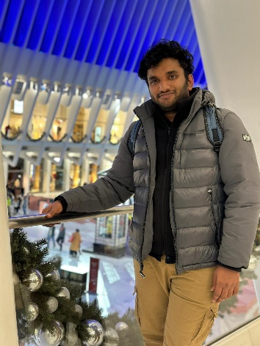 Name: Pranay Kumar Reddy Chamala

Email: pc66524n@pace.edu

Role: Lead AI & ML Engineer

Responsibilities:

* Develop AI-driven models to process medical images and analyze user symptoms.
* Train and optimize machine learning algorithms to improve diagnostic accuracy.
* Debug and optimize AI models for faster and more reliable outputs.
* Document coding practices, testing strategies, and AI/ML model details for future scalability.

 Name: Murali Kummari

Email: mk36335n@pace.edu

Role: AI & ML Engineer & Tester

Responsibilities:

* Develop AI-driven models to process medical images and analyze user symptoms.
* Train and optimize machine learning algorithms to improve diagnostic accuracy.
* Validate AI model accuracy and performance through rigorous testing methods.
* Assess AI-generated recommendations to ensure they align with medical standards.
* Document coding practices, testing strategies, and AI/ML model details for future scalability.

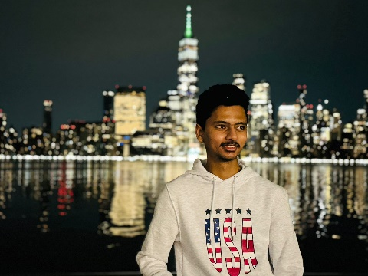 Name: Uday Kumar L

Email: ul55671n@pace.edu

Role: AI & ML Engineer & Tester

Responsibilities:

* Develop AI-driven models to process medical images and analyze user symptoms.
* Ensure seamless integration of AI insights into the doctor’s workflow for better decision-making.
* Validate AI model accuracy and performance through rigorous testing methods.
* Assess AI-generated recommendations to ensure they align with medical standards.
* Document coding practices, testing strategies, and AI/ML model details for future scalability.